Hernandez, Sebastien B.
BSIT – 4A
PART 1 — COMPANY PROFILE
Company Name
SBH Startup Solutions
Nature Of Business
SBH Startup Solutions is a newly established software development company that provides web development, mobile application development, custom business systems, cloud-based solutions, and technical consulting services to small and medium-sized businesses.
The company relies heavily on computers, internet connectivity, development tools, communication platforms, secure data storage, and reliable network infrastructure.
Company Vision
To become a leading and trusted technology company recognized for delivering innovative, secure, and high-quality digital solutions that empower businesses to grow, improve productivity, adapt to technological advancements, and achieve long-term success in an increasingly digital world.
Company Mission
SBH Startup Solutions aims to deliver high-quality software and technology services while maintaining a secure, reliable, and scalable IT environment. The company is committed to continuously improving its technical capabilities, protecting organizational information, supporting employees, and adopting technologies that contribute to long-term business growth.
Office Location
2nd Floor, EDSA Central Square, Shaw Boulevard, corner Sto. Cristo Street, Greenfield District, Mandaluyong City, 1552, Philippines
Organizational Structure
CEO
Information Technology Departmen
- IT Manager / System Administrator
- Network Administrator
- Software Developer
- Software Developer
- IT Support Technician
Human Resources Department
- HR Manager
- (3) HR Staffs
Finance Department
- Finance Manager
- (4) Finance staffs
Sales Department
- Sales Manager
- (5) Sales Representatives
Employee Distribution
Department | Number of Employees | Percentage
Information Technology | 5 | 25%
Human Resources | 4 | 20%
Finance | 5 | 25%
Sales | 6 | 30%
Total | 20 | 100%
TOTAL of 20 Employees with 100% Contribution
Note: Some paragraphs in this md were developed with the assistance of ChatGPT to improve clarity, structure, and overall presentation while preserving the original ideas and intended content.

PART 2 — ENTERPRISE HARDWARE INVENTORY
Hardware Inventory
Asset ID | Hardware | Qty. | Department / Location | Purpose
HW-DT-001–014 | Business Desktop Computers | 14 | IT: 2, HR: 4, Finance: 5, Sales: 3 | Primary office workstations
HW-LT-001–006 | Business Laptops | 6 | IT: 3, Sales: 3 | Mobile work, presentations, remote administration and development
HW-SRV-001 | Enterprise Server | 1 | IT / Server Room | Internal applications, authentication, development services and virtualization
HW-RTR-001 | Business Router | 1 | Server / Network Room | Routes internal and external network traffic
HW-SW-001 | 48-Port Managed Switch | 1 | Network Rack | Connects wired computers, server, NAS, printers and access points
HW-PRN-001–002 | Network Multifunction Printers | 2 | HR / Admin Area and Finance / Sales Area | Printing, scanning and copying
HW-UPS-001 | 2000VA Online UPS | 1 | Server Room | Protects server, NAS and networking equipment
HW-UPS-002–006 | 1000VA UPS | 5 | Finance Department | Protects critical Finance workstations from short power interruptions
HW-AP-001–002 | Wireless Access Points | 2 | Office Floor | Provides secure Wi-Fi coverage
HW-NAS-001 | 4-Bay NAS Storage | 1 | Server Room | Centralized shared storage and local backups
HW-BK-001–002 | 8 TB External Backup Drives | 2 | IT Department | Offline and rotating backup copies
HW-MON-001–020 | 24-inch IPS Monitors | 20 | All Departments | Primary external displays
HW-DOCK-001–006 | USB-C Laptop Docking Stations | 6 | IT and Sales | Connects laptops to monitors, keyboards, mice and wired LAN

Desktop Recommendation
Recommended Specification
Processor: Intel Core i5 / AMD Ryzen 5 or better
Memory: 16 GB RAM
Storage: 512 GB NVMe SSD
Display: 14- or 15.6-inch Full HD
Wireless: Wi-Fi 6 or newer
Operating System: Windows 11 Pro
Battery: Minimum 8-hour practical target
Security: TPM 2.0 and biometric authentication where available
Laptop Recommendation
Recommended specification:
Processor: Intel Core i5 / AMD Ryzen 5 or better Memory: 16 GB RAM Storage: 512 GB NVMe SSD Display: 14- or 15.6-inch Full HD Wireless: Wi-Fi 6 or newer Operating System: Windows 11 Pro Battery: Minimum 8-hour practical target Security: TPM 2.0 and biometric authentication where available
Hardware Justification
The company requires exactly 20 primary computers for 20 employees. Instead of purchasing 20 desktops, six employees are given laptops to support mobility.
A 48-port managed switch provides considerably more capacity than the company currently requires. The unused ports allow the organization to add employees, additional servers, IP phones, security cameras, access points, and other devices without immediately replacing the core switch.
Two wireless access points provide better coverage and distribute wireless clients more effectively than relying on a single access point.
The NAS provides centralized storage while the two external drives allow backup media to be rotated, including keeping one copy disconnected or stored outside the primary server area.
Note: The hardware specifications and details presented in this section were developed with the assistance of ChatGPT to support accurate selection and understanding of hardware components that may be less familiar.

PART 3 — ENTERPRISE SOFTWARE INVENTORY
Software Inventory
Software | Version | License | Purpose
Windows 11 Pro | Current supported release | Commercial / Proprietary | Operating system for employee workstations
Ubuntu Server | 26.04 LTS | Open Source | Server operating system
Microsoft Office / Microsoft 365 | Current release | Commercial Subscription | Word processing, spreadsheets, presentations, and office productivity
Visual Studio Code | Current Stable | Free | Software development and code editing
Git | Current Stable | Open Source | Source-code version control
GitHub Desktop | Current Stable | Free | Graphical interface for Git and GitHub repositories
Oracle VirtualBox | Current Stable | Open Source / Free under applicable license | Virtual machine testing and laboratory environments
Google Chrome | Current Stable | Free / Proprietary | Web browsing and testing web applications
Microsoft Defender | Windows-integrated current version | Included with Windows | Endpoint malware protection
AnyDesk | Current Business Release | Commercial | Authorized remote technical support
7-Zip | Current Stable | Open Source | File compression and archive management
Microsoft Teams | Current Release | Commercial / Subscription | Company communication and online meetings
PowerShell | Current Windows Release | Included / Open Source components | System administration and automation

Software Justification
- Windows 11 Pro: will serve as the standard client operating system so users have a consistent, manageable environment.
- Ubuntu Server 26.04 LTS: will be installed on the company's primary server because it provides a stable Linux environment suitable for web services, internal development systems, containers, monitoring systems and other server workloads.
- Microsoft Office/Microsoft 365: is required by HR, Finance, Sales and management for documents, spreadsheets, reports, presentations and communication.
- VS Code, Git and GitHub Desktop: are particularly important to the IT Department because the company develops software and requires source-code management.
- VirtualBox: allows the IT team to create isolated virtual machines for learning, testing operating systems and testing configuration changes without affecting production equipment.
- Google Chrome: is needed for general internet access and for testing web applications.
- Microsoft Defender provides baseline endpoint security for Windows systems.
- AnyDesk: allows authorized IT personnel to provide remote technical support.
7-Zip: provides file compression and decompression for common archive formats.
Note: Some software-related details were prepared with the assistance of ChatGPT to help ensure the accuracy, clarity, and completeness of the information provided for each software application.

PART 4 — ENTERPRISE NETWORK INVENTORY
Network Equipment Inventory
Asset ID | Equipment | Qty. | Recommended Specification | Purpose
NET-001 | ISP Modem / Fiber ONT | 1 | ISP-provided | Terminates the fiber internet connection
NET-002 | Enterprise Router | 1 | Gigabit or multi-gigabit WAN/LAN | Routes internal and external network traffic
NET-003 | Next-Generation Firewall | 1 | VLAN, VPN, IDS/IPS capable | Secures and filters network traffic
NET-004 | Managed Network Switch | 1 | 48-port Gigabit / 2.5GbE PoE+ | Provides primary wired network distribution
NET-005–006 | Wireless Access Points | 2 | Wi-Fi 6 or newer, VLAN capable | Provides corporate and guest wireless access
NET-007 | CAT6 Patch Panel | 1 | 48-port | Organizes structured network cabling
NET-008 | CAT6 UTP Cable | 2 boxes | 305 meters per box | Provides structured office network cabling
NET-009 | RJ45 Connectors | 100 | CAT6 compatible | Supports cable termination and maintenance
NET-010 | Network Rack | 1 | 12U–18U | Houses network and server-room equipment
NET-011 | CAT6 Patch Cords | 40 | Various lengths | Connects patch panels, switches, and devices
NET-012 | CAT6 Keystone Jacks | 30 | CAT6 compatible | Provides network connections at wall outlets
NET-013 | Cable Management Panels | 2 | 1U rack mount | Keeps rack cabling organized and manageable

Network Segmentation
VLAN | Department / Purpose | Suggested Subnet
VLAN 10 | Information Technology | 192.168.10.0/24
VLAN 20 | Human Resources | 192.168.20.0/24
VLAN 30 | Finance | 192.168.30.0/24
VLAN 40 | Sales | 192.168.40.0/24
VLAN 50 | Servers and NAS | 192.168.50.0/24
VLAN 60 | Printers / Infrastructure | 192.168.60.0/24
VLAN 70 | Corporate Wi-Fi | 192.168.70.0/24
VLAN 80 | Guest Wi-Fi | 192.168.80.0/24

Note: Some details presented in this file were developed with the assistance of web-based research and AI tools to improve accuracy, clarity, and completeness.

PART 5- Enterprise Network Diagram
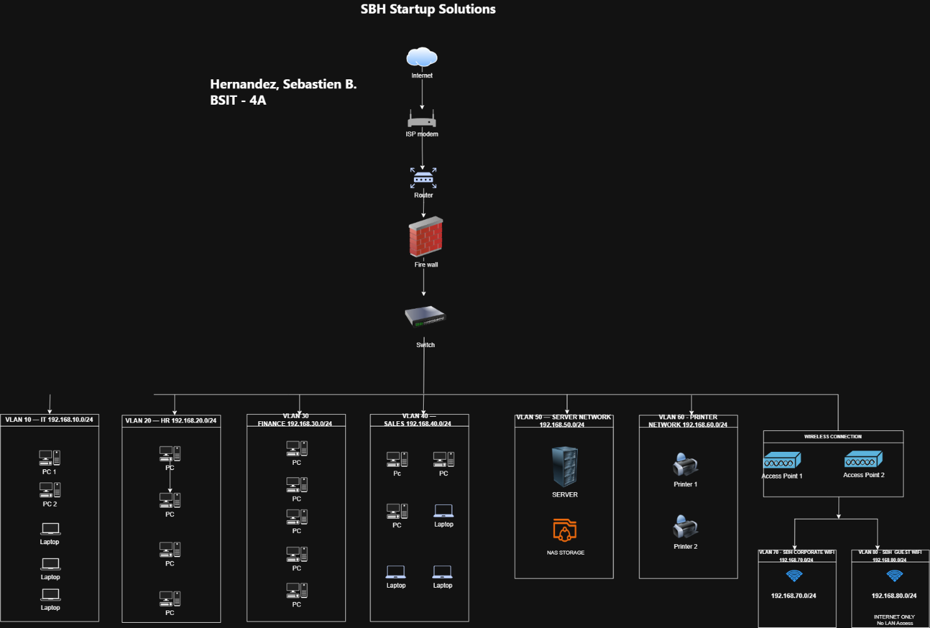

PART 6 - System Administration Roles
Helpdesk Technician
Responsibilities
A Helpdesk Technician provides first-level technical assistance to company employees. Responsibilities include troubleshooting computer problems, installing applications, resolving login issues, setting up user workstations, diagnosing printer problems, providing remote support and escalating complex problems to senior IT personnel.
Skills
A Helpdesk Technician should understand Windows operating systems, basic networking, hardware troubleshooting, software installation, user-account administration and customer service. Strong communication and documentation skills are also important because the technician regularly communicates with non-technical employees.
Common Tools
- Ticketing systems
- AnyDesk
- Remote Desktop
- Microsoft 365 Admin Center
- PowerShell
- Active Directory
- Windows Event Viewer
- Ping and IPConfig
- Hardware diagnostic utilities
Certifications
- CompTIA A+
- Cisco Certified Support Technician (CCST)
- Microsoft Fundamentals certifications
Network Administrator
Responsibilities
The Network Administrator designs, configures, maintains and troubleshoots organizational networks. Responsibilities include configuring routers, switches, firewalls, VLANs, wireless networks, IP addresses, VPN connections and network security policies.
The Network Administrator also monitors network performance and resolves connectivity problems.
Skills
- TCP/IP
- IPv4 and IPv6
- Subnetting
- VLAN configuration
- Routing and switching
- DHCP
- DNS
- VPN configuration
- Firewall management
- Network security
- Wireless networking
- Network troubleshooting
Common Tools
- Wireshark
- PuTTY / SSH
- Cisco IOS or equivalent network operating systems
- Ping
- Traceroute
- Nmap
- Network monitoring software
- Firewall management platforms
Certifications
- A common certification is Cisco Certified Network Associate (CCNA).
- Cisco states that its current CCNA covers networking fundamentals, network access, IP connectivity, IP services, security fundamentals, automation and programmability.
Cloud Administrator
Responsibilities
A Cloud Administrator manages computing resources hosted through platforms such as Microsoft Azure, Amazon Web Services or Google Cloud.
Responsibilities may include managing virtual machines, cloud storage, networking, identities, backups, access permissions, monitoring and cloud security.
Skills
- Cloud computing fundamentals
- Identity and Access Management
- Virtual machines
- Cloud networking
- Storage services
- Backup and disaster recovery
- Security groups and firewalls
- Automation
- Monitoring
- Cost management
Common Tools
- Microsoft Azure Portal
- AWS Management Console
- Azure CLI
- AWS CLI
- PowerShell
- Terraform
- Cloud monitoring platforms
- Git
Certifications
- Microsoft Certified: Azure Fundamentals
- Microsoft Certified: Azure Administrator Associate
- AWS Certified Cloud Practitioner
- AWS Certified Solutions Architect – Associate
- Microsoft's current Azure Administrator Associate credential focuses on configuring, managing, securing and administering Azure resources. AWS also currently provides foundational Cloud Practitioner and Solutions Architect Associate credentials.
The Helpdesk Technician, Network Administrator, Linux System Administrator, and Cloud Administrator work collaboratively to maintain a stable, secure, and efficient IT environment. The Helpdesk Technician serves as the first point of contact for users and handles common hardware, software, account, and workstation concerns. Network-related problems are managed by the Network Administrator, server and Linux-based services are handled by the Linux System Administrator, and cloud-hosted systems and resources are maintained by the Cloud Administrator. Each role has a specific area of responsibility, effective IT operations depend on strong coordination among them because business applications often rely on interconnected networks, servers, endpoints, security controls, and cloud services.

Part 7 — INFRASTRUCTURE RECOMMENDATIONS
Internet Provider
For a Manila-based startup, I recommend a business-grade fiber connection from PLDT Enterprise as the primary connection, subject to actual service availability at the office location. PLDT Enterprise currently provides business fiber products targeted at MSMEs and enterprise customers.
Recommended primary connection:
300–500 Mbps Business Fiber
A business connection is preferable to depending entirely on residential internet because company operations rely on software repositories, cloud services, online meetings, remote access and customer communications.
A second connection from another provider such as Converge Business should eventually be installed for redundancy if available in the building. Converge currently provides fiber connectivity specifically for business customers.
Using different providers decreases the possibility that a single ISP outage completely disconnects company operations.
Server Specification
Recommended server:
- Processor: 8-core or higher enterprise-class Intel Xeon or AMD EPYC processor
- Memory: 64 GB ECC RAM, expandable to at least 128 GB
- System Storage: 2 × 1.92 TB enterprise SSD in RAID 1
- Network: Dual Gigabit or 10 Gigabit Ethernet interfaces
- Power Supply: Redundant power supplies where budget permits
- Operating System: Ubuntu Server 26.04 LTS
- Virtualization: Virtual machines and/or containers when necessary
The server should initially host internal development services, monitoring systems, internal applications and other centralized services. Virtualization allows several services to run separately without purchasing an individual physical server for every workload.
Backup Strategy
- 3 copies of important data
- 2 different storage types
- 1 copy stored off-site
Proposed design:
Production Data -> Local NAS with automatic snapshots -> Encrypted External Backup Drive -> Encrypted Off-Site/Cloud Backup
The NAS should perform frequent local snapshots of critical company data.
Two external drives should be rotated so that one drive can remain disconnected from the network.
Important company data should additionally be encrypted and backed up to an approved cloud backup service.
Backup jobs should be monitored and test restorations should be performed regularly. A backup should not be considered successful until the company confirms that data can actually be restored.
Security Recommendations
The company should implement security from the beginning rather than adding protection only after an incident occurs.
Recommended controls include:
Next-generation firewall VLAN network segmentation Multi-factor authentication Least-privilege user access Separate administrator accounts Automatic operating-system and software updates Microsoft Defender endpoint protection BitLocker disk encryption for company laptops Encrypted backups Secure corporate Wi-Fi Completely separated guest Wi-Fi Firewall logging Centralized monitoring Employee cybersecurity awareness training Device inventory Documented incident-response procedures Regular vulnerability and patch reviews Account removal immediately after employee separation
CISA recommends core small-business practices that include enabling MFA, applying software updates and patches, and performing and testing backups.
Antivirus
All Windows 11 workstations should have Microsoft Defender Antivirus enabled and properly updated.
For stronger centralized administration, management should consider upgrading to Microsoft Defender for Business or another centrally managed Endpoint Detection and Response solution as the company grows.
Employees should not be permitted to disable endpoint protection without IT authorization.
Password Policy
Recommended organizational policy:
Minimum password/passphrase length: 15 characters
Users should be encouraged to use long, memorable passphrases rather than simple short passwords.
The company should:
- Block commonly used and compromised passwords
- Enable MFA for company services
- Require MFA for every administrator account
- Use a company-approved password manager
- Never allow employees to share passwords
- Never store passwords in plain text
- Change passwords immediately when compromise is suspected
- Protect password-reset procedures with identity verification
Current NIST guidance requires at least 15 characters when passwords are the only authentication factor and advises against mandatory periodic password changes unless there is evidence of compromise. It also advises against arbitrary composition rules such as forcing particular combinations of character types.
Therefore, SBH Startup Solutions should prioritize long passphrases, MFA and compromised-password detection rather than relying only on complicated password patterns.
Expansion Plan
The infrastructure should be designed for the company to grow from 20 employees to approximately 40–50 employees without completely rebuilding the network.
The 48-port managed switch provides spare network capacity.
The server should support memory and storage upgrades.
The network rack should have unused rack space.
Additional access points can be installed if wireless demand increases.
The VLAN architecture can support additional departments.
The NAS should support larger hard drives.
Cloud infrastructure can gradually host applications that no longer need to remain on-premises.
A second switch can eventually be installed and connected to the existing core network.
A secondary internet provider should be introduced when availability requirements increase.
This approach allows the organization to expand gradually rather than replacing the entire infrastructure every time the company hires new employees.
PART 8 — PERSONAL REFLECTION
Completing this Enterprise IT Infrastructure Plan helped me understand that System Administration is not only about installing an operating system, configuring a server, or troubleshooting computers. One of the most important responsibilities of a System Administrator happens before the actual installation begins: planning. Through this project, I learned how hardware, software, networking, security, backup systems, employees, and business requirements must all be considered when designing an IT environment.
One of the most challenging parts of the project was designing the network infrastructure. It was necessary to determine how computers from different departments would connect while also considering servers, printers, wireless devices, security, and future expansion. Creating separate VLANs for IT, Human Resources, Finance, Sales, servers, printers, corporate Wi-Fi, and guest Wi-Fi helped me understand how network segmentation can improve organization and security. I also learned that purchasing only the exact number of ports or devices currently required may create problems when the company expands.
Planning before deployment is important because infrastructure mistakes can become expensive once equipment has already been purchased and installed. For example, purchasing an undersized network switch could require an early replacement, while failing to create a proper backup system could result in permanent data loss. Security must also be planned from the beginning because a company that stores confidential employee, financial, business, and customer information cannot rely on default configurations alone.
The project also helped me understand how different System Administration roles depend on one another. Helpdesk personnel support employees, Network Administrators maintain connectivity, Linux System Administrators manage servers, and Cloud Administrators manage online infrastructure. Even though their responsibilities are different, they must communicate and work together to keep company services available.
This activity will help me become a better System Administrator because it trained me to think beyond individual computers and consider the organization as one complete system. Instead of immediately installing equipment, I learned to evaluate requirements, identify risks, design solutions, prepare for growth, and document my decisions. These skills are important because a professional System Administrator must build infrastructure that is not only functional today but also secure, manageable, reliable, and scalable in the future.

